**WEEK #3**

**OBJECTIVES**

* To help the students in learning the concepts of C++.
* To help the students in learning the different tools for C++ programming on different software platform.
* To help the students in installing the C++ tool kit in their computers.

**OUTCOMES**

After completing this, the students would be able to:

* Understand the concepts of C++.
* Setup the C++ environment on different platform.

**PROBLEMS**

**1# Dev C++ IDE: Installation, Features and C++ Development**

**Step 1:-**Download the C++ package installer form the official website and double click.

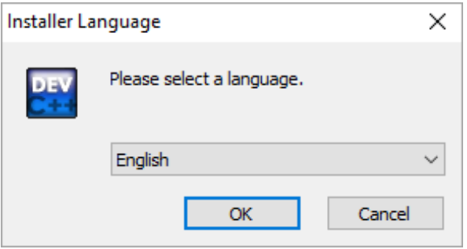

**Step 2:-**Accept the agreement and click the next.

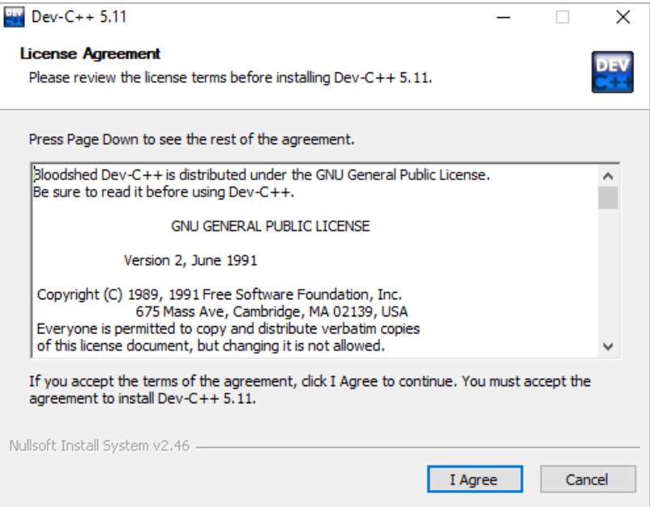

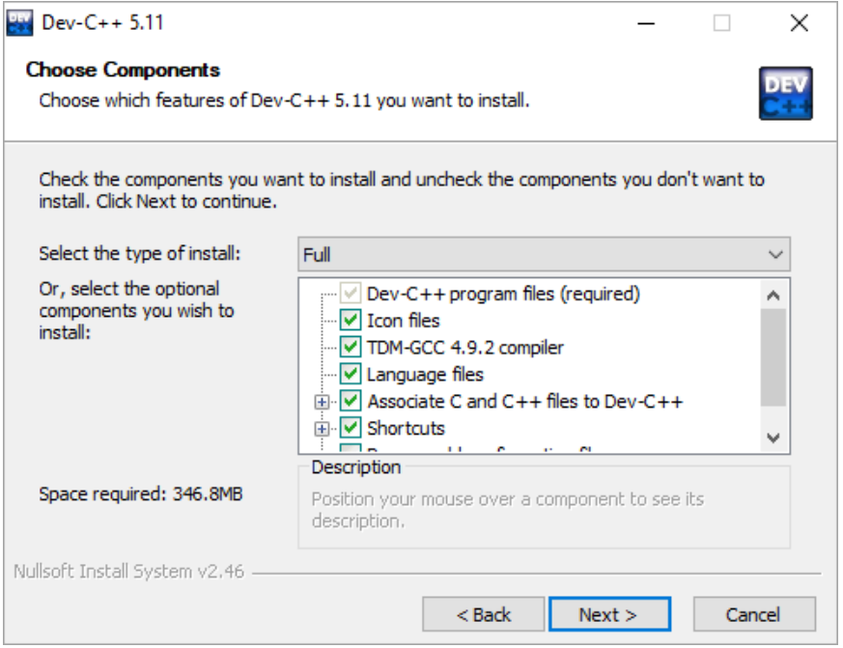

**Step 3:-**Choose the path for installing cpp.

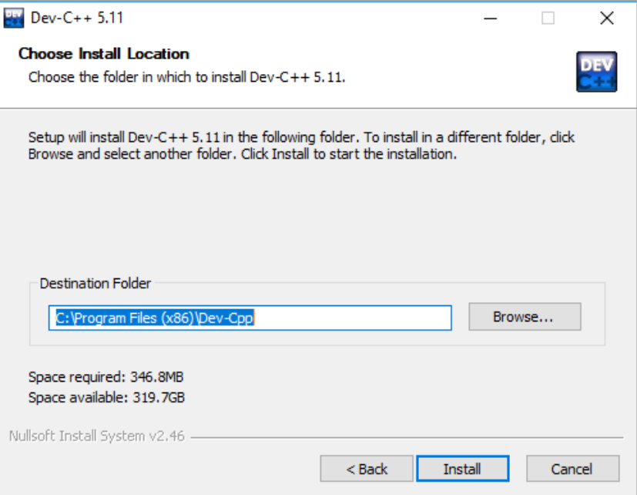

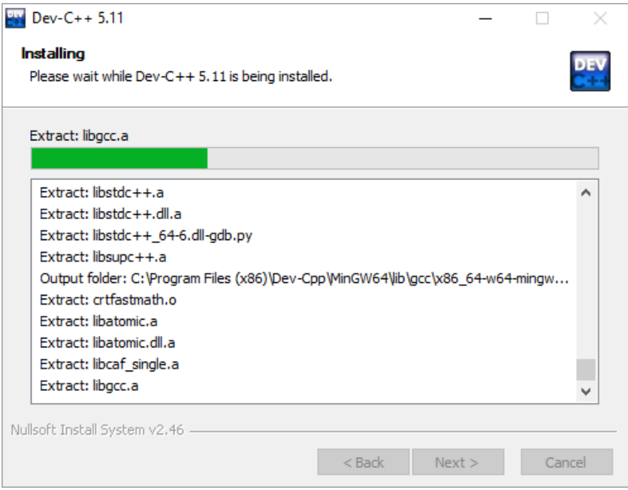

**Step 4**:- Choose the English language as your language.

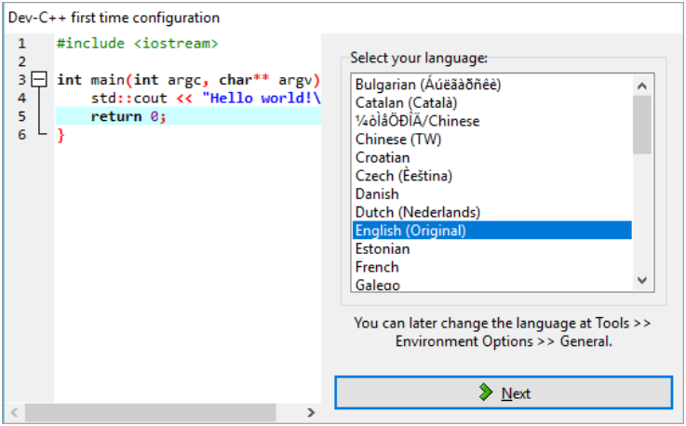

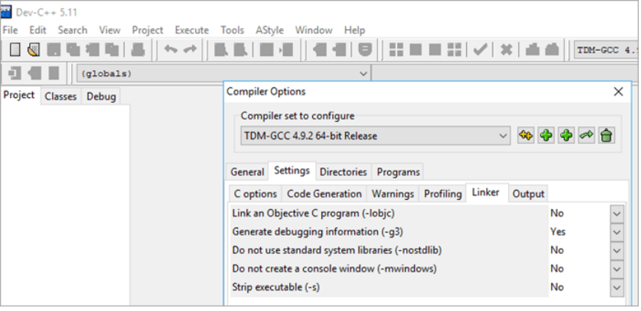

**Step 5:-** To create a new project in dev-C++ we need to follow the below steps: • Click File → New → Project. • A new dialog opens up as shown below.

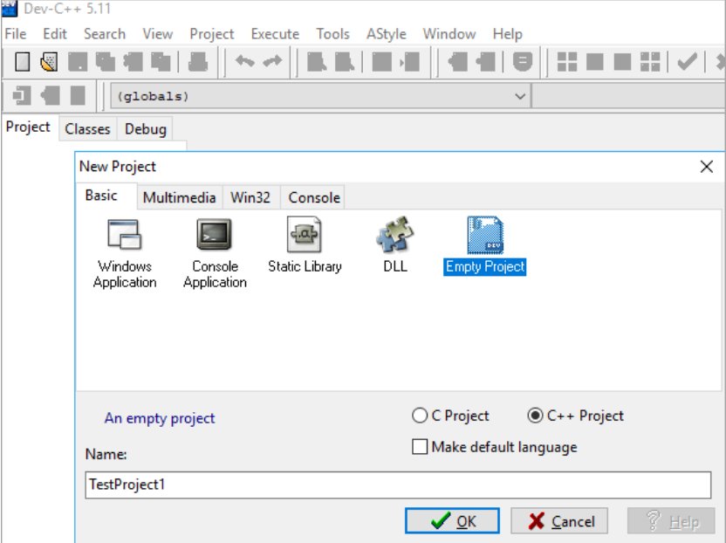

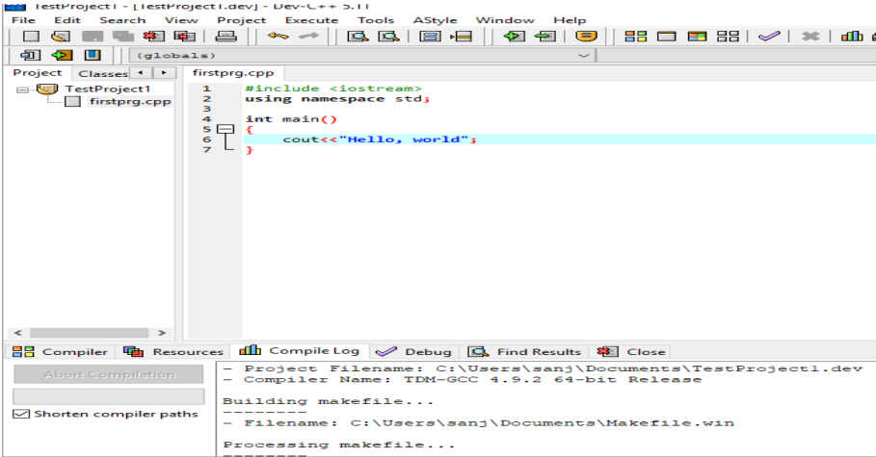

**Step 6:-** Follow the below steps to debug the program using Dev-C++ IDE:

• Click Execute→Debug. (or click F5).

• Once the debug is clicked, we get the debug menu in the IDE, asshown below.

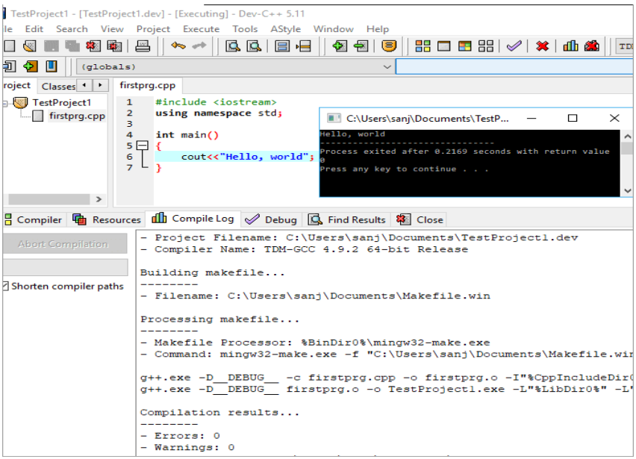

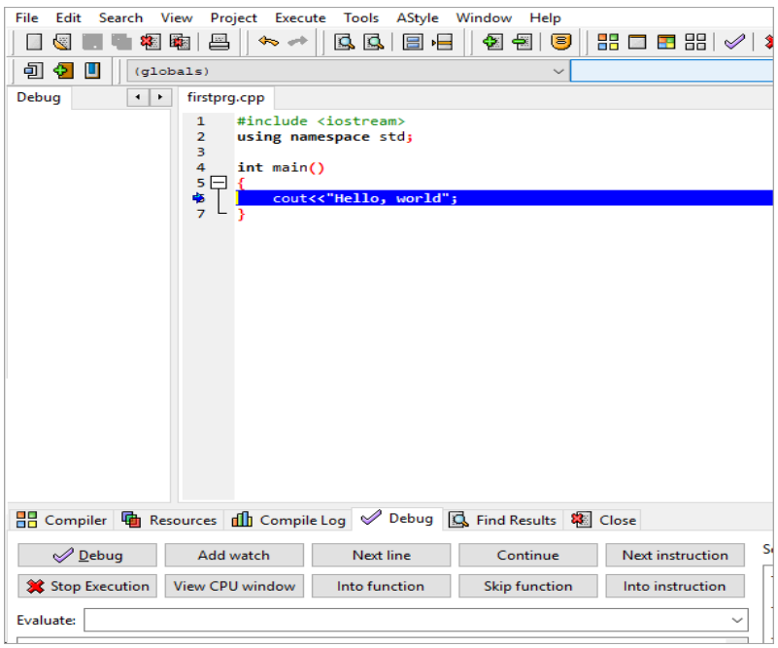

**Step 7**:- Setting up Code::Blocks on Windows

Download Code::Blocks

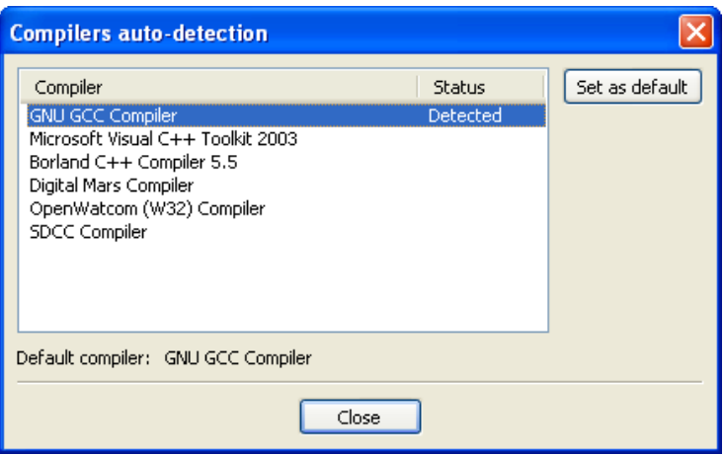

Install Code :: Blocks

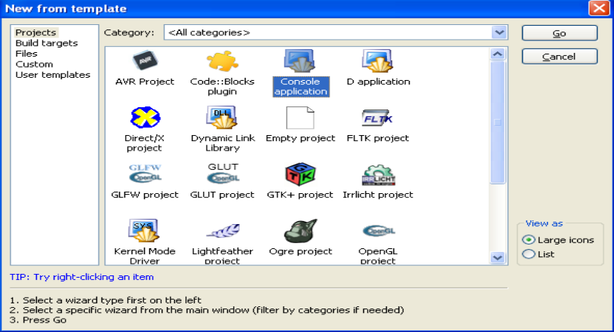

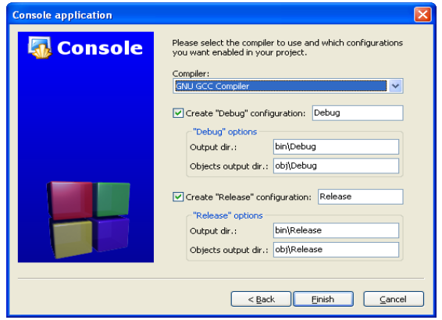

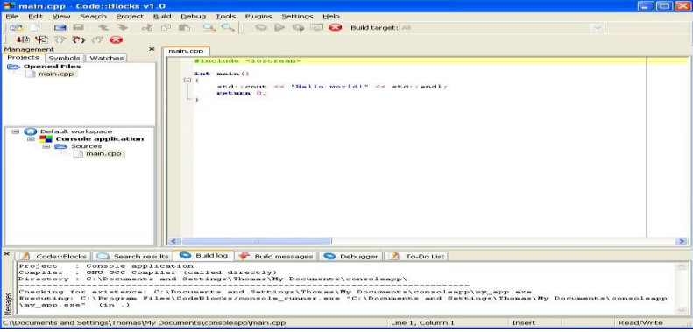

Running in Code: Blocks

